Videogame about a sweatshop
On 9 November, 1982, US surgeon general Dr Everett Koop gave a speech at the Western Psychiatric Institute and Clinic in Pittsburgh, in which he challenged America to confront the causes of domestic violence and child abuse. After the speech, he took a question from an audience member asking whether he thought video games had a negative effect on young people. Yes, he replied. Teenagers were becoming addicted "body and soul" to video games, a form of entertainment in which "everything is 'zap the enemy', there's nothing constructive".
From that day video games – the youngest and therefore the most misunderstood and feared entertainment medium – have struggled to shrug off the perception that they are violent, often mindless, occasionally sexist and fundamentally unconstructive. The medium's big-ticket blockbusters reinforce the viewpoint with their cacophonies of buckshot and Michael Bay-esque blooms of explosion. Video games may share DNA with chess, but their likeness is often that of adolescent power fantasy.
But look deeper, and this medium wields an unusual power. Literature and film are passive experiences whereas the screen game is interactive. A book or movie allows us to commune with another mind, but only in the role of an onlooker or eavesdropper. Video games, by contrast, allow us to inhabit another's shoes and, moreover, to see whether we would make the same choices when faced with their particular set of problems and circumstances.
Sweatshop, a game I helped design for Littleloud, places players in an unusual pair of such shoes – those of a middle manager at a factory that supplies clothing to British high street retailers. Players must hire and fire the workers who stitch together baseball caps, trainers and sweatshirts. To maximise profits (and gain the highest score) the players have the option to hire cheaper child workers, speed up the belts to increase the work rate, neglect to hire fire officers and to generally cut corners. Video game players have been trained for efficiency and know how to work systems in order to maximise score – just like a sweatshop factory manager.
As play progresses, the game begins to reveal the effects of this way of working, of viewing workers as mere "units". There is a human consequence to the player's bowing to those economic pressures bearing down upon the factory manager. Whereas a film documentary might piece together the sweatshop story through footage and anecdote, the game allows players to experience the system from the inside with all its cat's cradle of pressures and temptations. Where there is a danger with a documentary or article that it can be didactic, a game can present the system in a more objective manner thereby building a different sort of empathy and understanding.
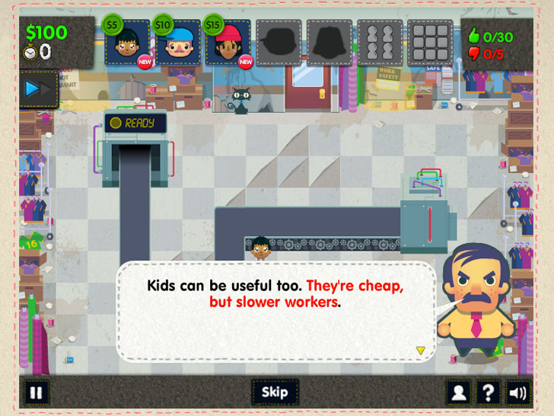
Sweatshop was released for free on the internet in 2011 generating widespread discussion both of the game and of the sweatshop problem in general. The game became the subject of an Massachusetts Institute of Technology paper on so-called "serious" games, while another group used it to educate clothing buyers for a British high-street retail chain.
Following its success, Littleloud created a version of the game for Apple's iPad, launched onto the App Store at Christmas. But Apple removed Sweatshop from sale last month stating that it was uncomfortable selling a game based on the theme of running a sweatshop. The team behind the game amended the app to clarify that Sweatshop is an educational work of fiction created with the fact-checking input of charity Labour Behind the Label, and to emphasise that the game doesn't force players to play the game in one way or another, explaining that Sweatshop is a sympathetic examination of the pressures that all participants in the sweatshop system endure. Sadly, these clarifications and changes weren't enough to see the game reinstated for sale.
Apple's developer guidelines are generally unclear on what style of content will be considered unsuitable. But they do have this to say: "We view apps different than books or songs, which we do not curate. If you want to criticize a religion, write a book. If you want to describe sex, write a book or a song, or create a medical app. It can get complicated, but we have decided to not allow certain kinds of content in the App Store."
Apple is, of course, at liberty to curate the type of content is hosts for sale. But while literature, film and music are not subject to this sort of heavy-handed curation, the message is clear: certain topics are off-limits for games (although not, for example, killing and maiming other virtual characters as in so many games on App Store). Any game hoping to educate and illuminate a controversial issue could be considered taboo (something evidenced by Apple's removal of trafficking satire SmuggleTruck and Endgame: Syria in recent months).
Regardless of the broader concern over a handful of content holders having control over what social commentary and criticism is permissible, the deeper fallacy – that games cannot speak in this way – is the more tragic one. The need for the "serious game" label is infuriating. As if we would speak about films or novels in such patronising terms.
In his 1982 ode to game obsession, Invasion of the Space Invaders, Martin Amis questioned whether video games aren't just improving their player's geometrical and spatial awareness but rather providing a means to search for the meaning of life. Sweatshop is a game with more humble ambitions. It hopes only to help players search for an understanding of the world, and the consequences of their actions within it – a freedom no right-minded or clear-conscienced corporation would seek to suppress.
The Guardian: 2013. A serious videogame about sweatshop. Available at: https://www.theguardian.com/commentisfree/2013/mar/22/sweatshop-game-apple-app-store, last updated March 22, 2013.
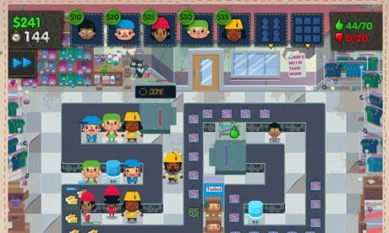
Follow-up tasks:
- What makes videogames such a special kind of popular media?

- What are some of the negative stereotypes surrounding videogames?

- Summarize some of the benefits of videogames mentioned in the article.

- Apart from the sweatshop issue, what other topics do you think VG should explore? Should they even get political and become “edutainment” instead of entertainment?

- Is it possible to replace traditional “classroom” education with modern media?

